Project: ORDER KRAFT ORDER MANAGEMENT SYSTEM
Group Number: 01
Squad Members:
1) L. Rohit Kumar
2) V. Sai Vivek
3) L. Sri Datta Kiran
4) B. Aditya Jyothir

1.INTRODUCTION:
This document provides a structured, end-to-end guide for setting up and running the Order Kraft full-stack application in a local development environment. It is designed to support new developers, testers, or stakeholders by providing clear explanations of the required tools, their purpose, installation procedures, and execution workflow.

3. MODULE DESCRIPTIONS:
Entire system is divided into five primary functional modules. Below is the complete breakdown of each entities associated with modules individually.

3.1 ADMIN MODULE
Responsible for managing system access and overseeing user administration. Maintains user authentication details, assigned roles, and permission levels for all system users.

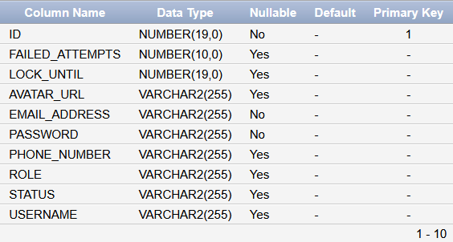

3.2 PRODUCTION DASHBOARD MODULE
Manages and supervises the manufacturing workflow, from production requests to the completion of final products. Personnel responsible for monitoring, coordinating, and controlling production line operations.

PRODUCTION_SCHEDULE: Creates production schedules by assigning the required units and workers based on the specific product requirements.
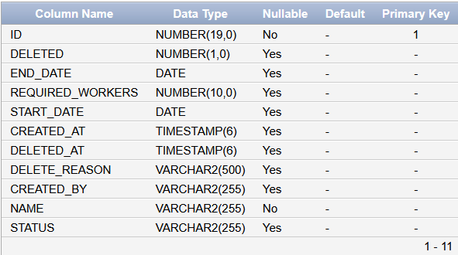
PRODUCTION_TASK: Defines and organizes the individual tasks required to produce the final product, assigning the necessary machines and workers for each task.
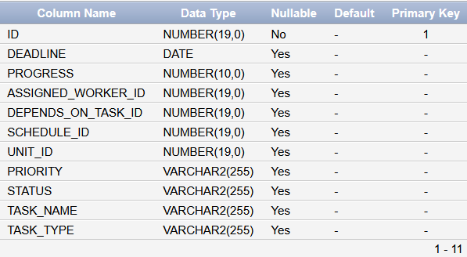

PRODUCTION_UNIT: a functional operational section containing various machines and equipment that perform specific tasks within departments such as Production, Packaging, and Shipping to support the overall manufacturing workflow.
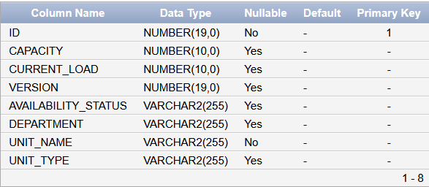

PRODUCTION_REPORT: Section responsible for generating reports based on system activities, operational performance, management data, and overall dashboard functionality.
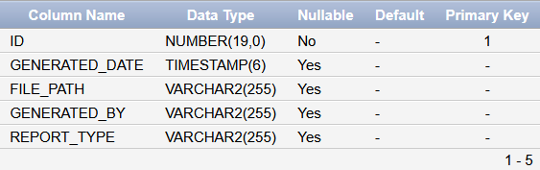

MAINTENANCE_SCHEDULE: Responsible for identifying and categorizing units that require maintenance due to mechanical issues, operational faults, or other system-related problems.
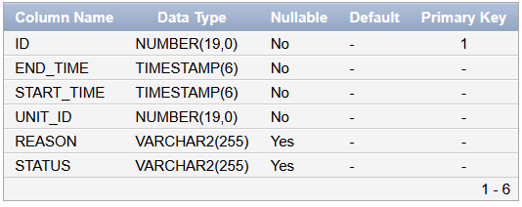

WORKERS: Responsible for assigning workers to specific tasks within a schedule based on their availability.
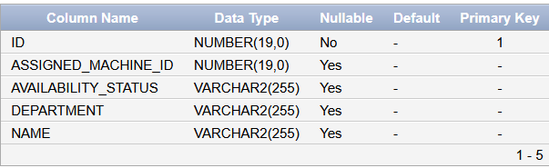

SCHEDULE_ALLOCATED_MACHINES: Allows modification of tasks when necessary, including updates to the machines assigned in the schedule during its creation.
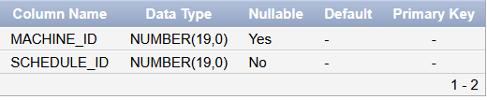

SCHEDULE_PACKAGING_MACHINES:
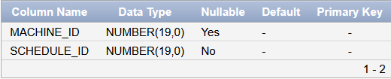

SCHEDULE_PRODUCTION_MACHINES
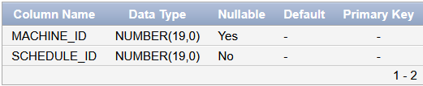

SCHEDULE_SHIPPING_MACHINES
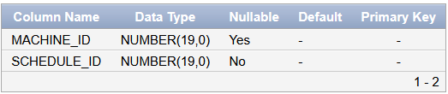

SCHEDULE_PACKAGING_WORKERS
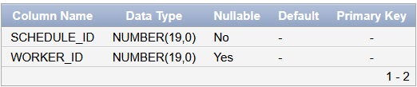

SCHEDULE_PRODUCTION_WORKERS
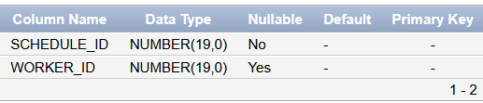

SCHEDULE_SHIPPING_WORKERS
